Physics Stage 3: Electricity and Magnetism Assignment

Name: ANSWERS (33 marks)

- Draw the field around the following situations:
  - an iron ball bearing between a horseshoe b. the field around a solenoid (including
magnet. (2 marks) north and south ends. (2 marks)
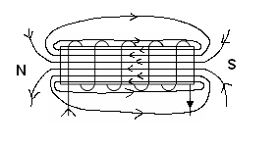
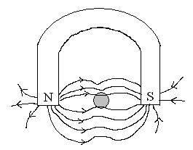

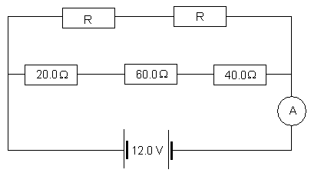
- Two identical resistors are set up in the following circuit. Determine the value of each unknown resistor if the ammeter reads 0.250 A. (3 marks)

V_{T} = 12.0 V 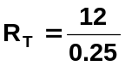
I_{T} = 0.25 A R_{T} = 48.0 Ω

R (middle) = 20 + 60 + 40 = 120 Ω
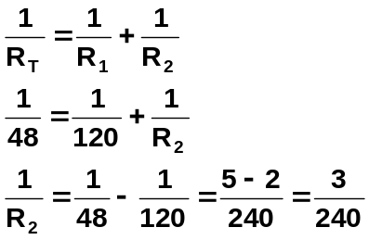

OR I (middle) = 12 ÷ 120 = 0.1 A
I (top) = 0.25 – 0.1
= 0.0.15 A
R (top) = 12 ÷ 0.15 R₂ = 240 ÷ 3 = 80
= 80 Ω so each resistor is 40.0 Ω
and as two resistors in series,
each resistor must be 40.0 Ω
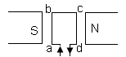

- If a coil, which has 300 turns has sides ab and cd of 5.50 cm and side bc of 3.50 cm, what is the force on side abl when a current of 0.500 A is passed through it. The field strength from the magnets is 8.30 x 10⁻¹ T. (3 marks)

F = nBI
= 300 x 8.30 x 10⁻¹ x 0.5 x 0.035 [1 mark]
= 4.36 N upwards
[1 mark] [1 mark]

- A 15.5 g wire which is 20.0 cm long is placed in a magnetic field of 0.500 T and is observed to float within the field as shown below.

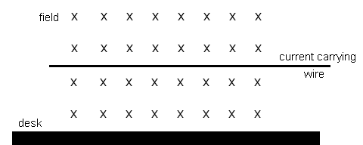

Calculate the size of the current. (3 marks)

F_{g} = F_{e}
mg = BI
0.0155 x 9.8 = 0.5 x x 0.20
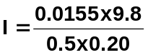

I = 1.52 A

- A horizontal conductor, AB, of length 2.40 cm is moving downwards at 0.450 m s⁻¹ at 90⁰ to a horizontal magnetic field of 6.70 x 10⁻³ T as shown.

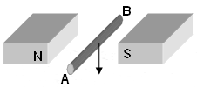

a. What is the magnitude of the emf induced in the conductor? (2 marks)

emf = Bv
= 6.7 x 10⁻³ x 0.024 x 0.45
emf = 7.24 x 10⁵ V

b. Which end, A or B, becomes positively charged? ____ A ______ (1 mark)

- Janelle is sitting in her study working on her Exploring Physics problems. She is cold so she turns on her heater which has a resistance of 215 Ω. If she runs the heater for 6 hours on the 240 V power supply, how much energy did the heater add to the room. (3 marks)

energy = Work = P x t and P = 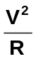
so energy = 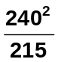x (6 x 60 x 60)

energy = 5.79 x 10⁶ J

- High voltage lines enter a factory which requires 11.0 MW to operate its machines efficiently. The voltage supplied to the system to achieve this power is 540.0 kV. Calculate the energy lost as heat in the transmission lines if the total resistance in the lines is 7.00 Ω and the energy is supplied for 6.00 hours. (3 marks)

current in line, P = VI
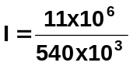
I = 20.37 A

Power lost as heat
P = I²R
= 20.37² x 7
= 2904.66 W

Energy lost over 6 hours
Energy = W = Pt
= 2904.66 x (6 x 60 x 60)

Energy = 6.27 x 10⁷ J

- A piece of iron is bent into a U shape and a coil is wound on each arm of the U as shown. One coil is connected to a 30.0 V A.C. power supply and the other is connected to a globe. Initially the iron bar at the top is absent. The iron bar is them slowly moved into position to sit on top of the iron ‘U’ as shown.

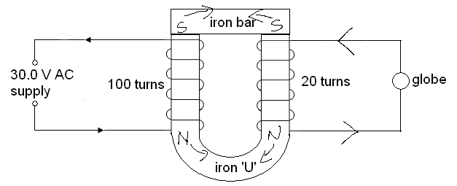

  - As the iron bar is moved closer and placed on top of the iron ‘U’, the globe: (circle correct response) (1 mark)

  - Explain why the globe can glow in the first place and thus explain your choice in (a) above. (3 marks)

As there is a changing magnetic field from AC supply, an emf is induced in the coil to the right which induces a current. The current allows the globe to glow.

When gap in iron ‘U’ completed with the iron bar in stead of air, induced emf higher as iron is a magnetic material thus increasing the magnetic field and increasing the emf and current induced.

  - At a particular instance in time, the direction of current is shown on the left hand side of the diagram. Draw in the direction of current flowing through the globe. (1 mark)

  - What is the magnitude of the voltage passing through the globe. (1 mark)

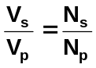
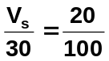 ; 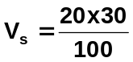
V_{s} = 6.00 V

- A rectangular coil of sides 5.00 cm is within a magnetic field of 2.50 x 10⁻² T. The coil has 324 turns on it and it rotates 50 times every second.

  - Calculate the induced emf in the coil. (3 marks)

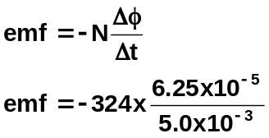A = 0.05 x 0.05
= 2.5 x 10⁻³ m²
φ = BA
= 2.5 x 10⁻² x 2.5 x 10⁻³
= 6.25 x 10⁻⁵ Wb

50 rev = 1.0 s emf = -4.05 V
0.25 s = t

t = 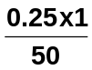= 5.0 x 10⁻³ s

  - A similar coil is also rotated at 50 times every second. The emf produced is measured and the coil produces a maximum emf of 5.00 V. Sketch a graph of emf vs time for this coil starting when the coil is horizontal. Label this graph 1. (1 mark)

  - On the same graph, sketch the graph for the emf vs time for the same coil if the magnetic field were halved. Label this graph 2. (1 mark)

